Keyhole Pattern

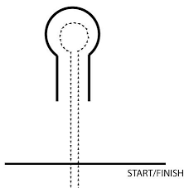

Laneway Length – 5 m
Laneway width – 1.5 m
Hole Diameter - 4 m

